P 001 Attacking Under Pressure
Pressure grid, the sprinting, defending and shooting grid.

Requirements: Half a pitch two teams, a goal with net and keeper two posts, markers

General Scenario: Players line up as shown and change places after each run. On the coach's call. a defender passes a ball through a mini goal then sprints to defend, an attacker collects the passed ball and tries to get a shot on goal.
Teams split into two groups. Defenders (A) (Red) with a ball each, move off of the goal line marker (1) and pass the ball through a mini goal (2) towards another post in midfield, the defender (A) then runs into play around a post (3) and tries to defend or pressure the shot on goal (4) against the attacking player, Player (B) (Blue).
Attacker Player (B) moves off the marker (1) on or near the half way line ONLY when the ball is passed through the mini goal, then sprints around a post (2), collects the ball (3) and tries to get a shot on goal (4). Returning players shown in (Orange).

Players swap places after each move i.e. defenders become attackers, attackers collect the ball and become defenders.

Play commences: On coach's call and when the first defender (A) passes the ball through a mini goal (2) towards a post in midfield.

G001 Grid layout showing markers and posts - Right side set up
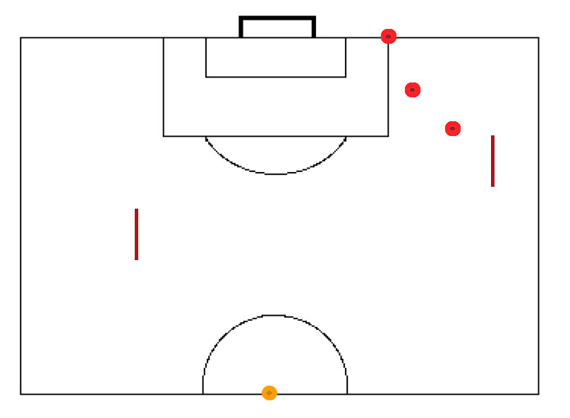
Professional Players
i. Make attackers dribble the ball into penalty area.
ii. Make players shoot on sight – using a volley from where they receive the ball.
iii. Switch to left side of the field and make players shoot wrong footed.
iv. Make attacker cut inside to shoot from right side of pitch, (defender to hold and cover).
v. Make defender sprint to goal and work defensive moves with keeper, staying between attacker and goal line.
vi. Make attackers dribble the ball into penalty area. Defender to stand up (not dive in for the tackle) - must chase and worry the attacker until tackled or shot ensues.
vii. Attacker to control the ball then stop it and wait for the defender to come, then try to beat the defender in 1 v 1.
viii. Attacker to try to chip the ball over the defender then shoot on the volley or bounce or as soon as possible for goal.
ix. Attacker to push and go past the defender, two or more touches, both players to chase down the ball.

Phase ii.
iv. Use a chip or lobbed ball (throw in) so than incoming attacker must control a bouncing ball.
v. Use variations in shooting, power pass, chipping the keeper, shoot for one side of the goal etc.
vi. Bring in one defender in penalty area (only) in front of the keeper, move the grid further into the pitch to give a longer run for the attacker, the attacker now has two defenders to beat.
vii. With the above in place have one extra attacker moving up and down the middle to act as wall pass player (this player is the wall). The attacker is the ONLY one who can be tackled or can shoot for goal.
viii. Make attackers sit at the marker at the start of each run.
ix. Attacker can only score with a header played as a return from an extra attacker – this has to touch a marker mid pitch attacker

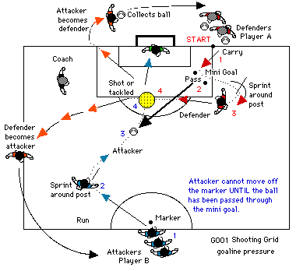

Roles: Defenders Make a good weighted pass (towards the field post (2)) then sprint around your post (3) as shown and try to get in front of the attacker and prevent the shot on goal (4). Attacking players Take off from their marker (1) at speed, turn at post (2) control the ball (3) and try to get a shot on goal (4).

Targets: Defenders to get to their position early, turn sharp at the post (3) towards a position between the attacking player and the goal, prevent a shot on goal, tackle the attacker, or force the player wide, spoilt the shot on goal in 1 v 1 situation.

Attacking players to control the ball quickly, get a clean shot on goal, dribble past the defender or shoot from long range. (As indicated by the coach - two touch or carry into penalty area)

Goalkeepers: Come out to defend or cover long range shots as you feel necessary, talk to and encourage your defender. Be aggressive in shot saving.

Coaching Points - This is an aggression building sprint grid, rather than have players line up to take a pot shot on goal here we have pressure, speed and real game action. Look for both players speed off the mark, DEFENDER (Red) to make a good (fair) weighted push pass. ATTACK player, (Blue) encourage speed off the mark, (no cheating - do not allow attackers to creep off marker (1)). correct poor ball control at speed, look for early body position for shooting and the placement of the shot, i.e. shooting using the drive, knee over the ball, head forward - power - accuracy (player to pick spot) etc.

GOALKEEPER : Encourage the keeper to dominate the role of the defenders, let your keeper call defender position or action to help in team work (Use spare keeper as quick change over if one is available). Help keeper with correct positioning for long range shots and skill in coming out or in smothering attack players dribbling into the area. DEFENCE (Red) speed in getting into position for covering and denying a shot on goal from a 1 v 1 situation under pressure, quality of the first pass, (correct if poor), i.e. side of boot push pass, top of boot power pass. You set situations i.e. Attacker shoot as soon as possible, carry into area, Defender chip pass, lob pass, etc. In all actions correct poor technique and take player to one side for special practice - it is important that player learn their skills at the training ground, do NOT let poor skill level remain - CORRECT IT. Bring in more players into this grid to add competitiveness. Use this grid for three consecutive sessions (see developments & Phase ii progression for next weeks run).

Note: Move the posts to be more realistic i.e. to increase or decrease timing of runners. Set your routine to suit your team structure.

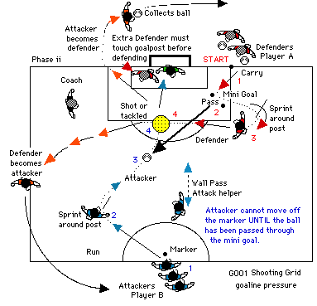

Note: The extra attacker (wall pass) has to chase back and touch the mid pitch marker (Orange) after each run before assisting the incoming player (change this attacker frequently).

For larger groups, You could create another group of attackers starting from the halfway line at the touchline intersection, see extra Orange marker, they can only enter when the ball is played but must touch the midfield marker before joining the attack.

